
University of Frontier Technology, Bangladesh
Department of Internet of Things and Robotics Engineering

Course Code | CC 483
Course Title | Cloud Computing

LAB REPORT-11 Solution
AZ-104: Implementing Data Protection
Azure Backup & Site Recovery — IaaS Virtual Machine Protection
Submitted To
Farzana Akter
Assistant Professor
Department of Internet of Things and Robotics Engineering
University of Frontier Technology, Bangladesh
Submitted By
SI | Class Roll | Name | Session
01 | 2201022 | Mst. Esat Jahan Akhi | 2022-2023
02 | 2201021 | Most.Sukria Akter | 2022-2023

Date of Submission
August 23, 2026

1. Executive Summary
This report outlines the implementation of complete data protection and disaster recovery strategies for Azure Virtual Machines (IaaS). The deployment encompasses two primary pillars: Azure Backup for operational, point-in-time recovery and Azure Site Recovery (ASR) for business continuity across paired geographic regions.

2. Architecture Overview
- Primary Region: Indonesia Central (az104-rg-region1)
- Secondary Region: Korea Central (az104-rg-region1-asr / az104-rsv-region2)
- Protected Workload: Virtual Machine (az104-10-vm0)
- Core Protection Services: Recovery Services Vaults, Azure Backup Policy, Azure Storage Diagnostics, and Azure Site Recovery.
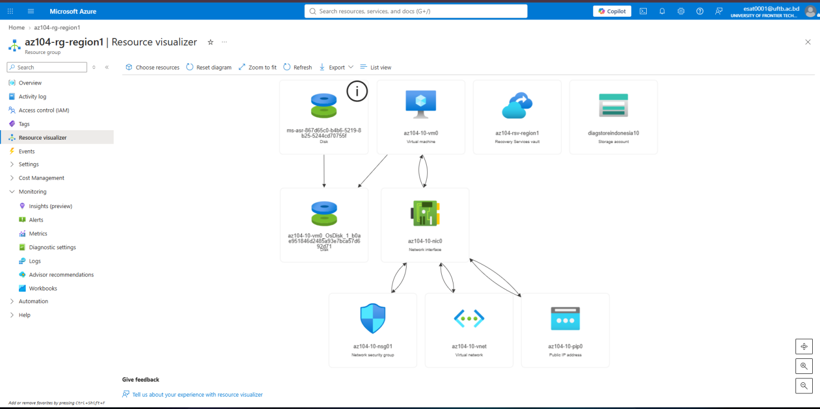

3. Step-by-Step Task Execution & Verification
Task 1: Deploy Provisioning Infrastructure
Deployed the core primary infrastructure using ARM templates, establishing az104-10-vm0 inside az104-rg-region1 along with associated networking and storage resources.
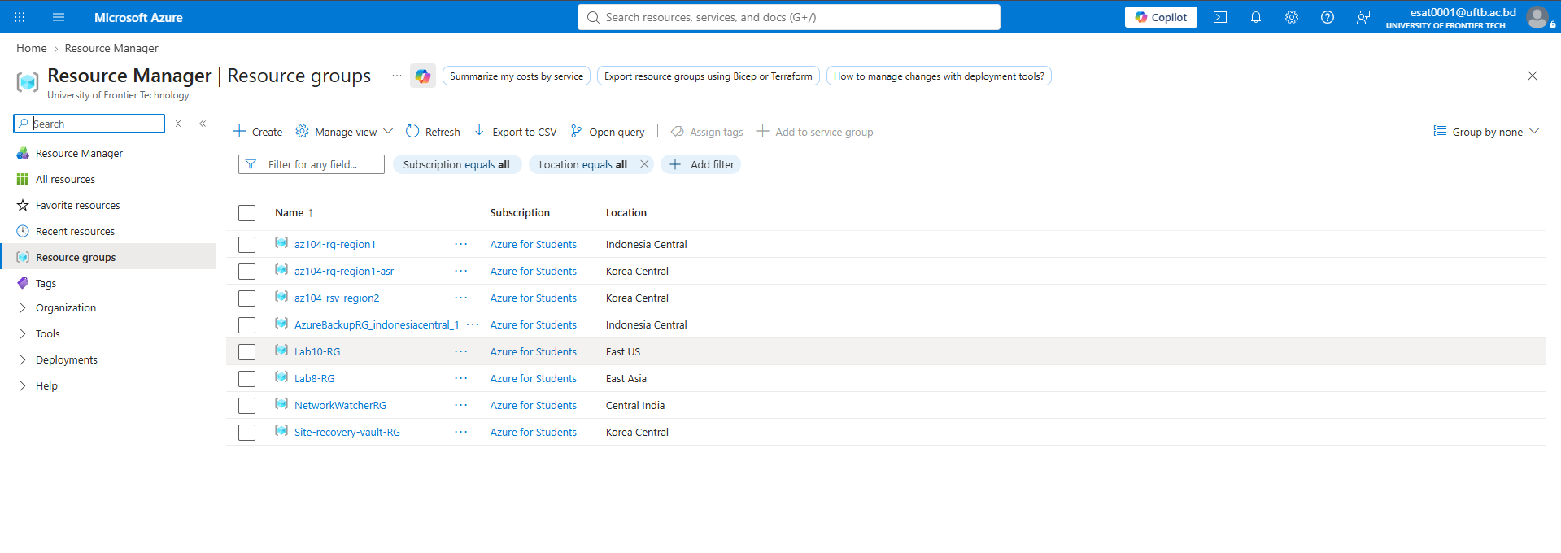
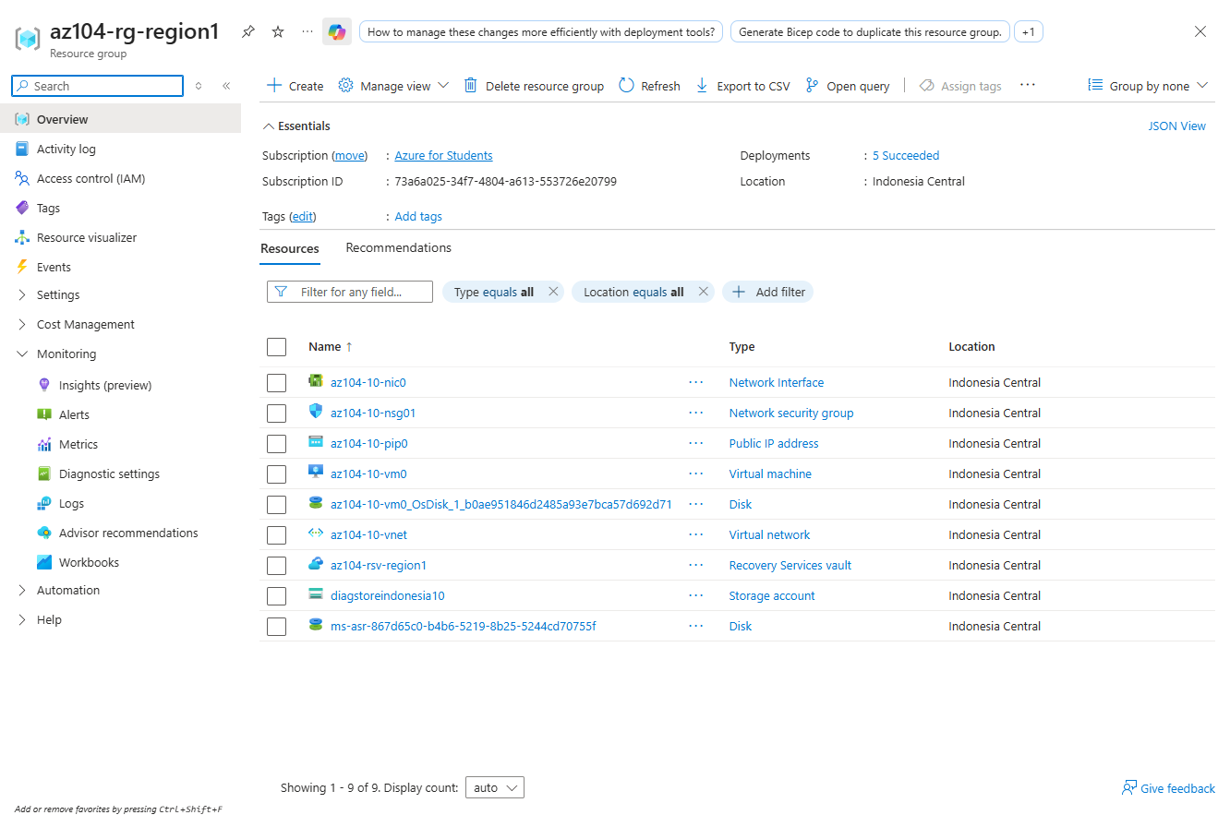
Task 2: Create Recovery Services Vaults
Created two Recovery Services Vaults in separate geographic locations to segregate local operational backups from disaster recovery management.
- az104-rsv-region1 — Indonesia Central (Primary Vault for Local Backups).
- az104-rsv-region2 — Korea Central (Secondary Vault for Disaster Recovery).
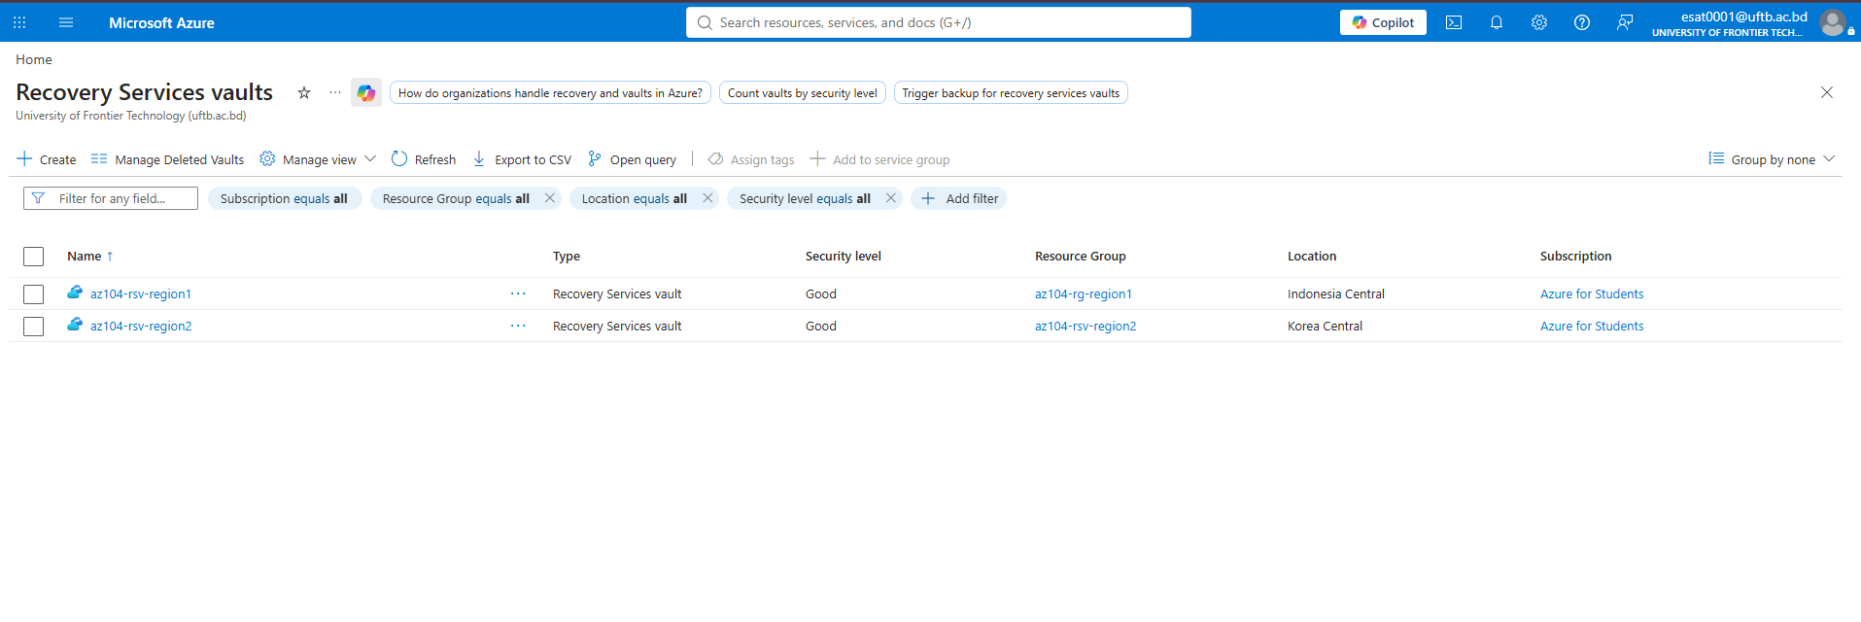
Task 3: Configure Azure Virtual Machine Level Backup
Configured daily VM backup policies and bound az104-10-vm0 to az104-rsv-region1. Initiated an on-demand manual backup operation to validate backup pipeline connectivity.
Configuration Details:
- Policy Name: az104-backup-policy
- Frequency: Daily at 12:00 AM UTC
- Retention: Instant recovery snapshot (2 days), Daily retention (180 days).
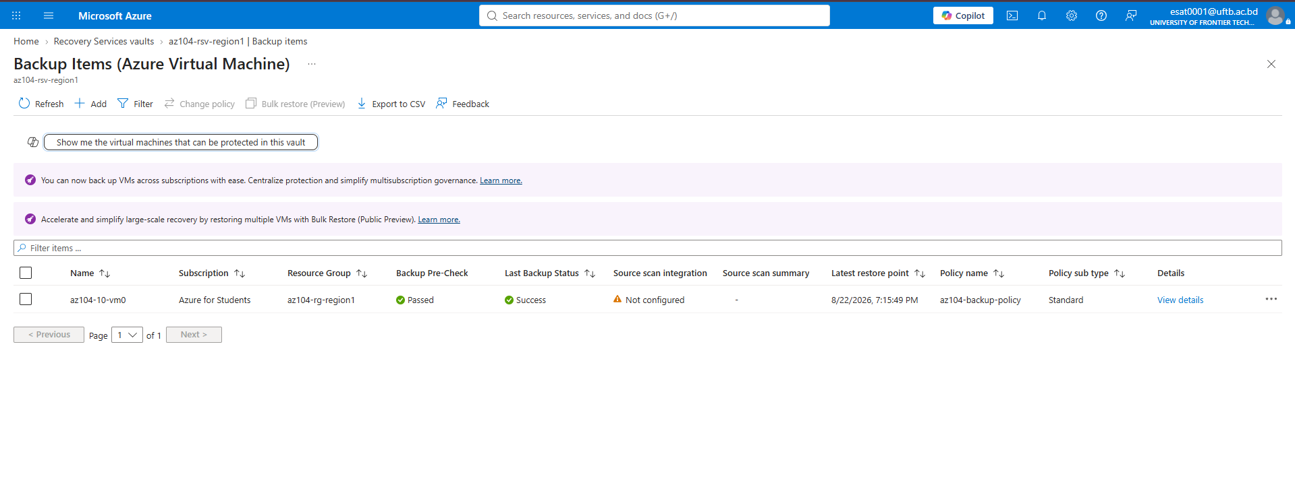
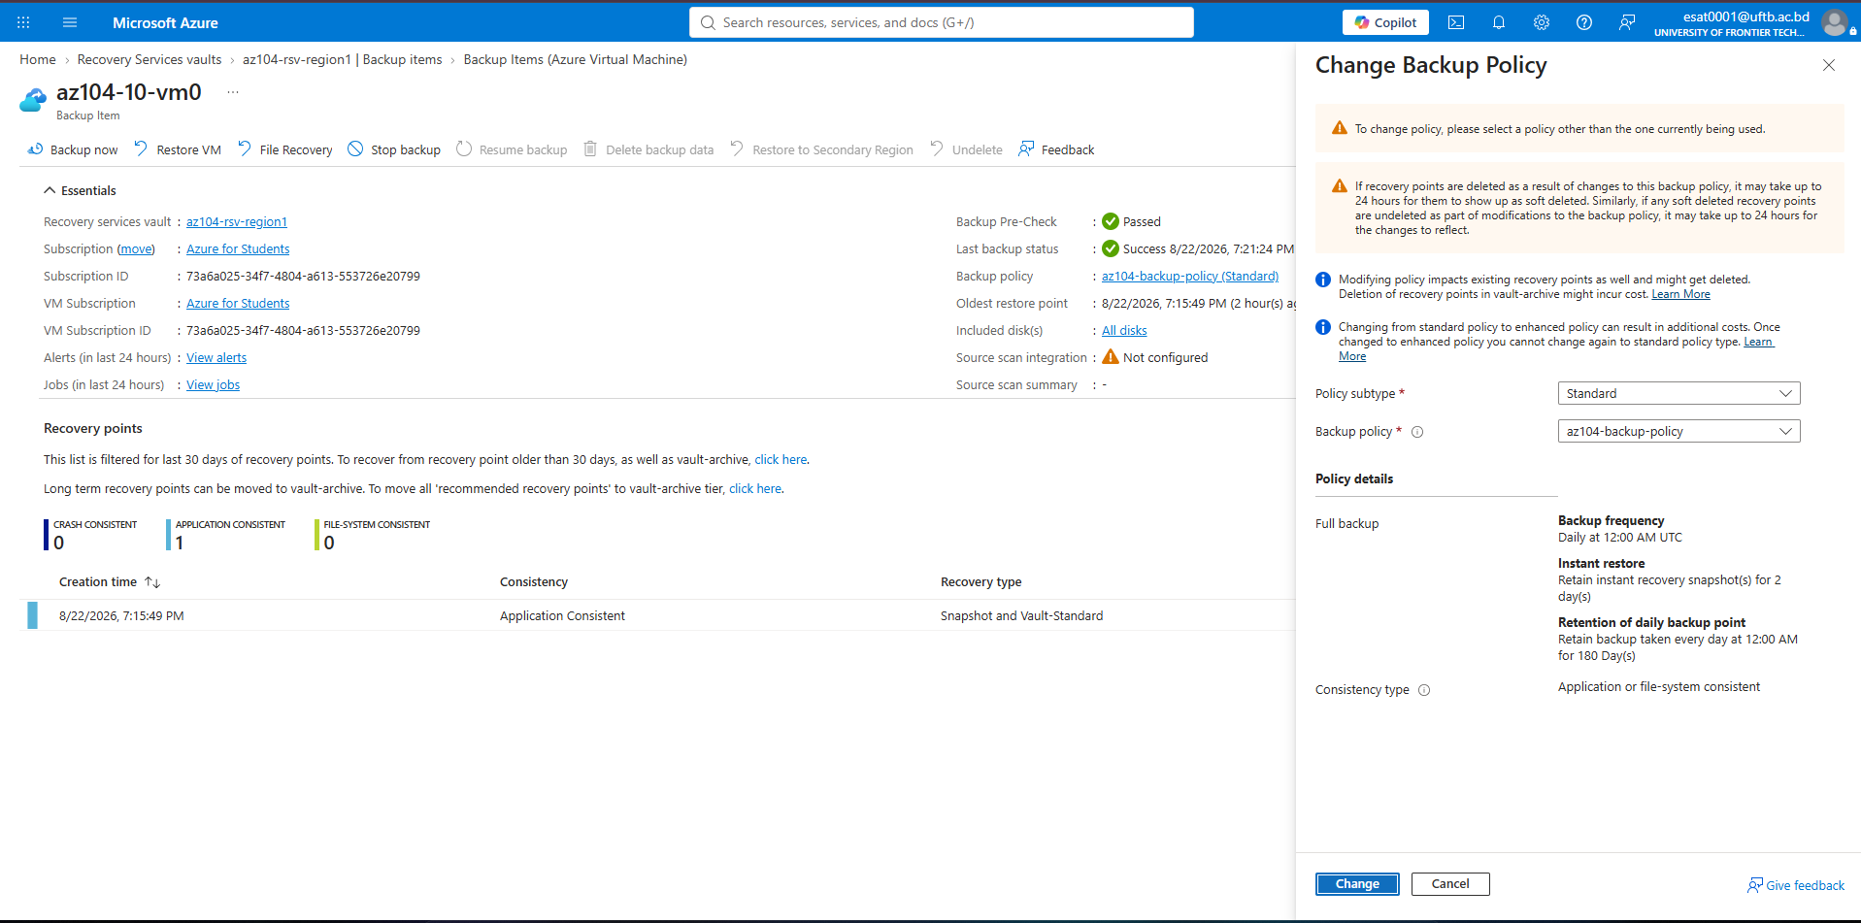
Task 4: Implement Diagnostic Settings
To support auditing and log retention, a diagnostic Storage Account (diagstoreindonesia10) was created. Vault logs and metrics were configured to archive to this storage destination.
Log Categories Forwarded:
- Azure Backup Reporting Data
- Addon Azure Backup Job Data
- Addon Azure Backup Alert Data
- Azure Site Recovery Jobs
- Azure Site Recovery Events
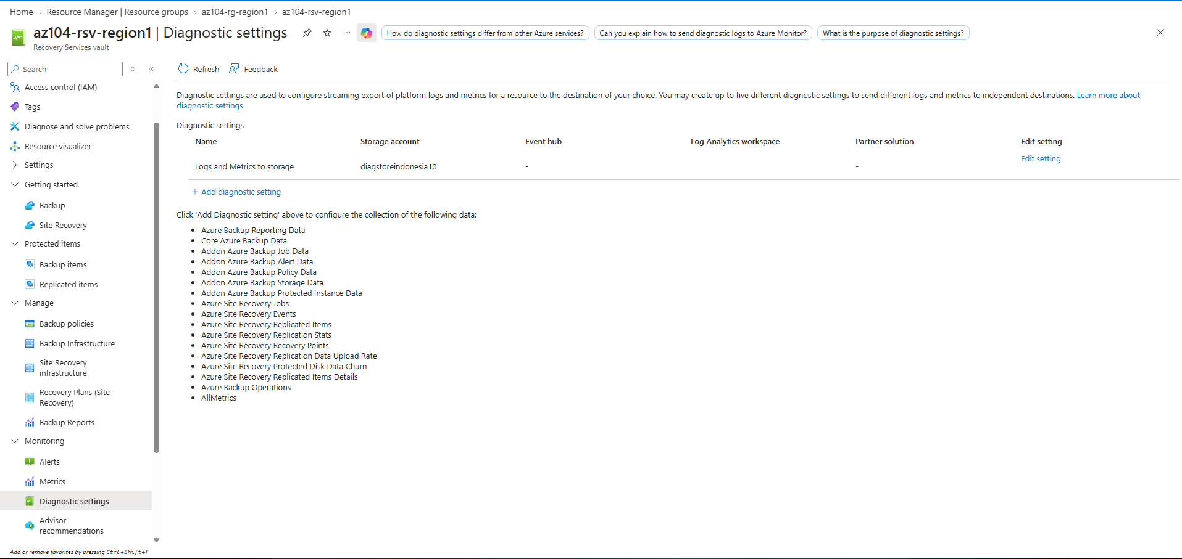
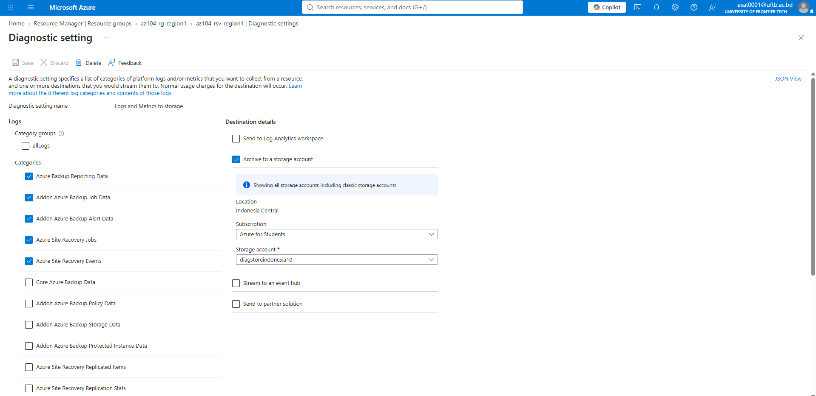
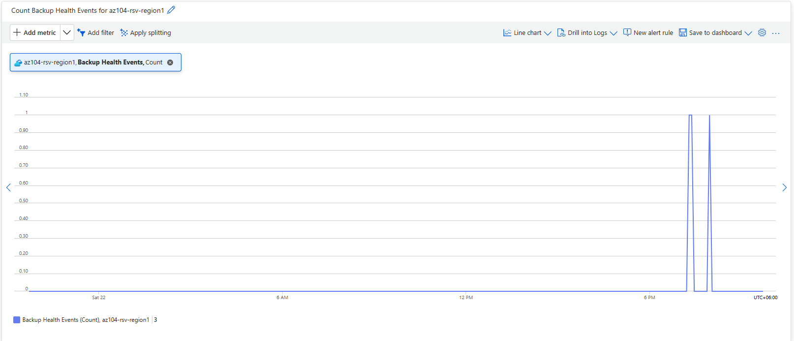
Task 5: Implement Azure Site Recovery (ASR) Disaster Recovery
Configured cross-region disaster recovery for az104-10-vm0 from Indonesia Central to Korea Central. To bypass automation account creation restrictions under the Azure for Students subscription, update settings were explicitly set to Manage manually.
Target Configuration Summary:
- Source Region: Indonesia Central
- Target Region: Korea Central
- Target Resource Group: az104-rg-region1-asr
- Target Virtual Network: az104-10-vnet-asr
- Extension Settings: Manage manually
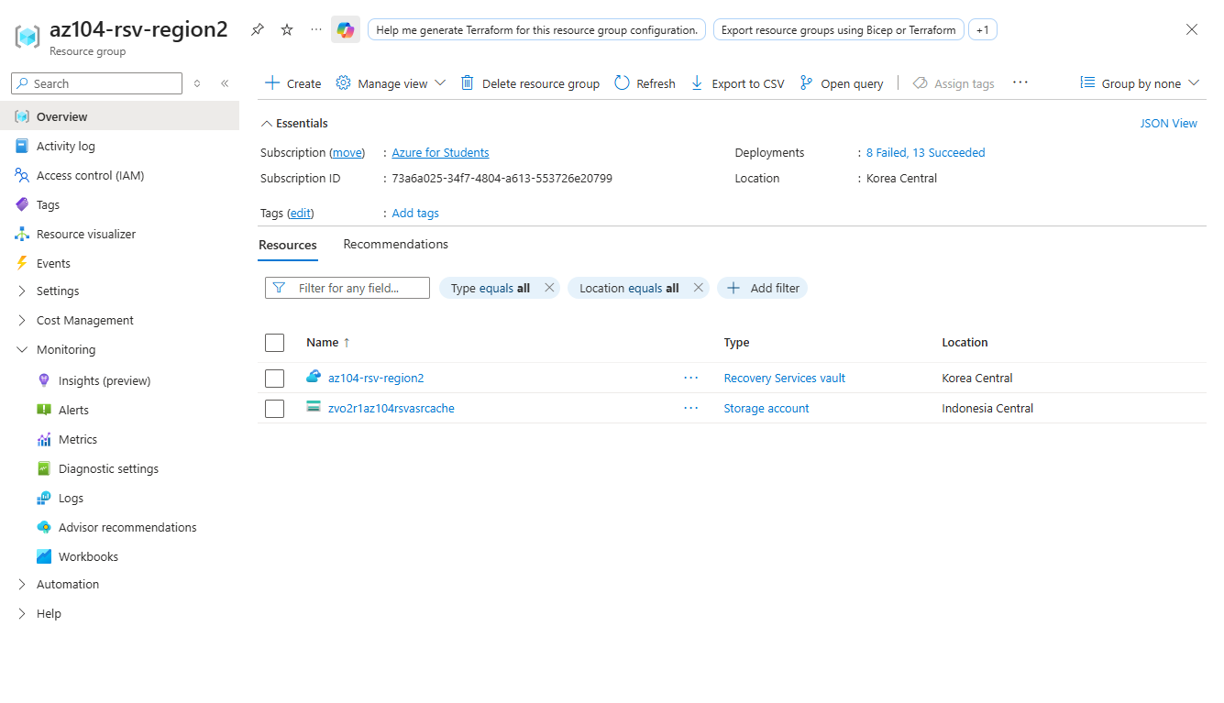

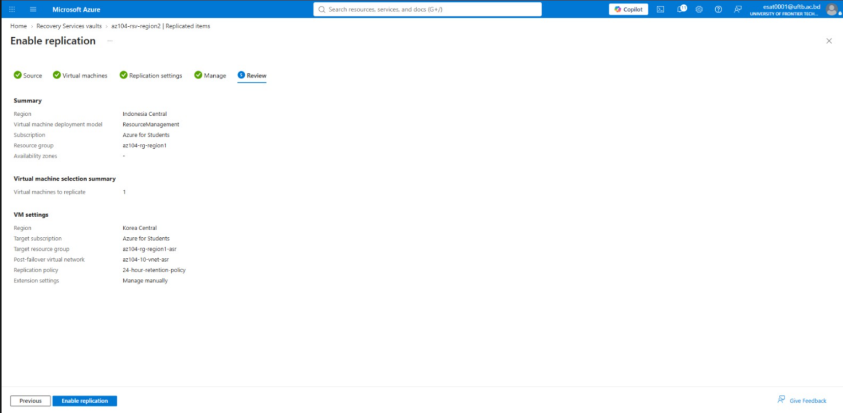
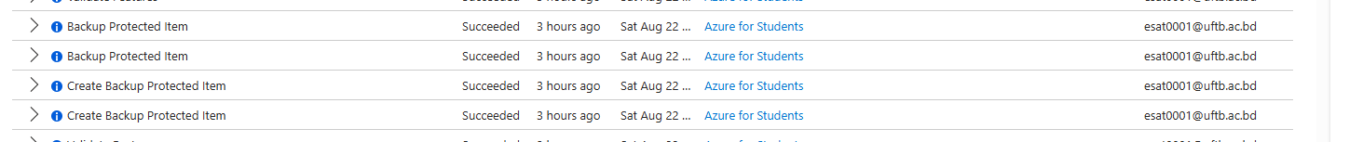

4. Final Outputs & Verification

Output 1: ASR Replication Status (Secondary Vault)
Verification confirms that cross-region disaster recovery replication is active inside the secondary Recovery Services Vault.
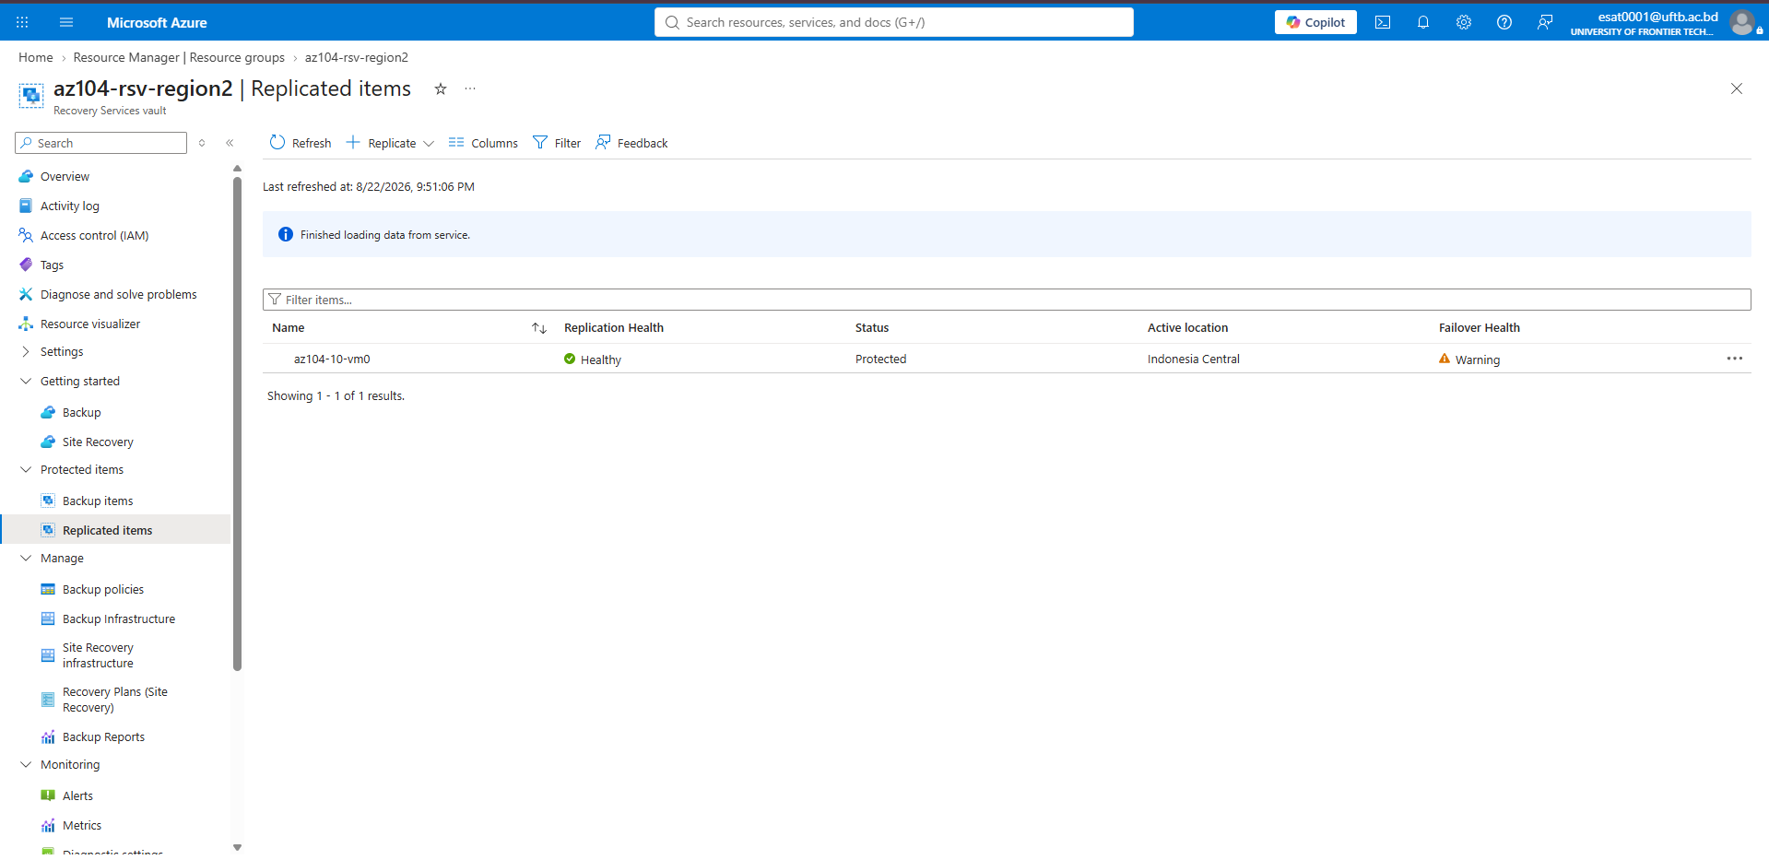

Output 2: Virtual Machine Backup Status (Primary Vault)
Verification confirms that operational backup protection is actively maintained within the primary Recovery Services Vault.
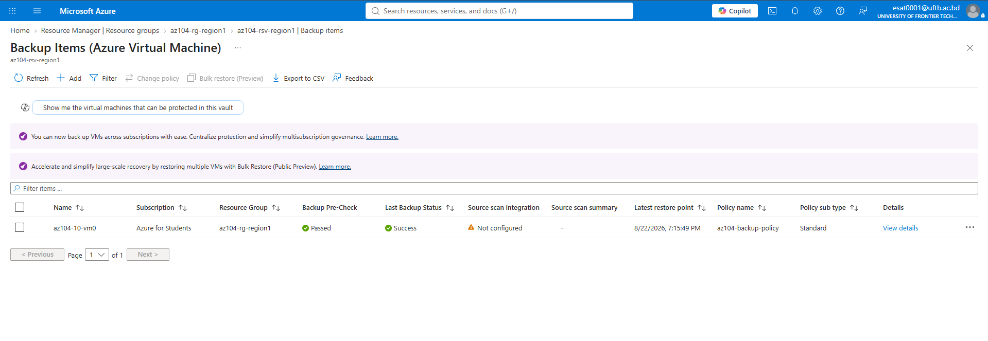
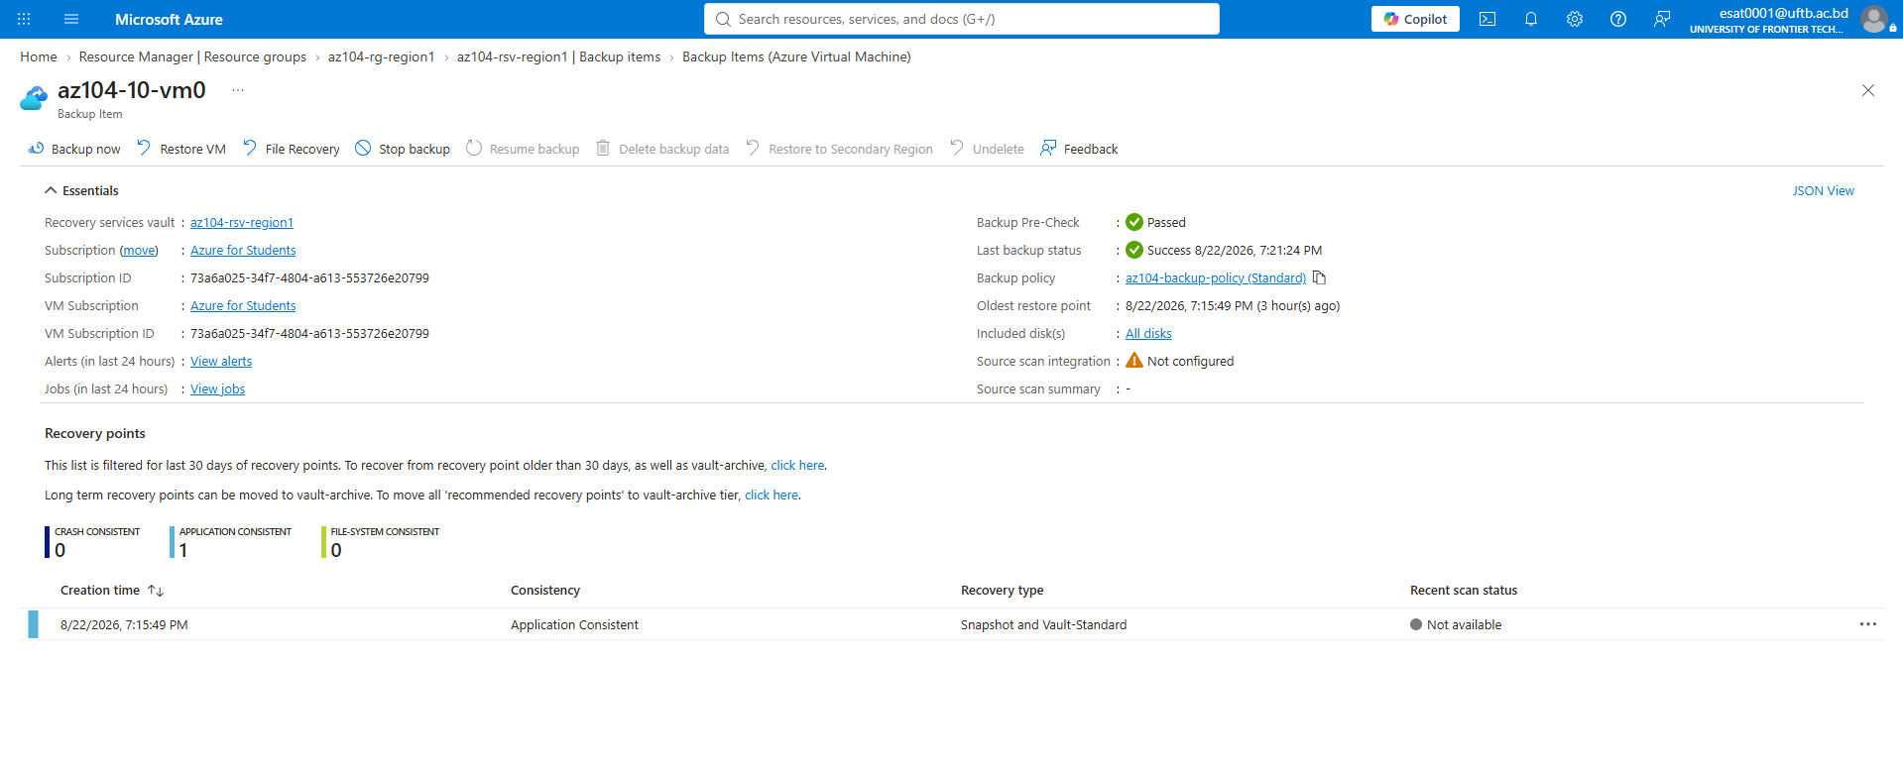

Output 3: Cross-Region Topology Map
Visualization of the active protection link established between the primary and target regions.
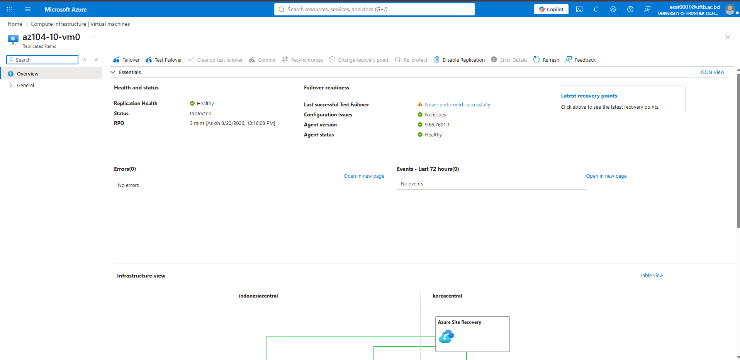
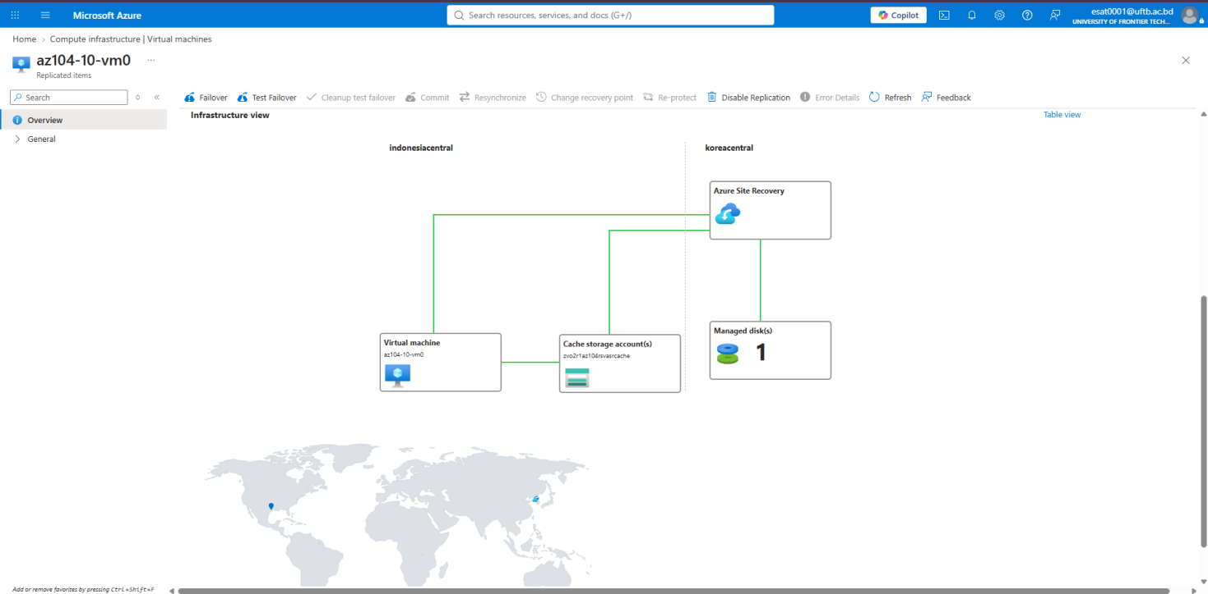
The presence of the insights-logs-azurebackupreport container and its inner telemetry directories validates that vault diagnostics are actively writing logs to diagstoreindonesia10.
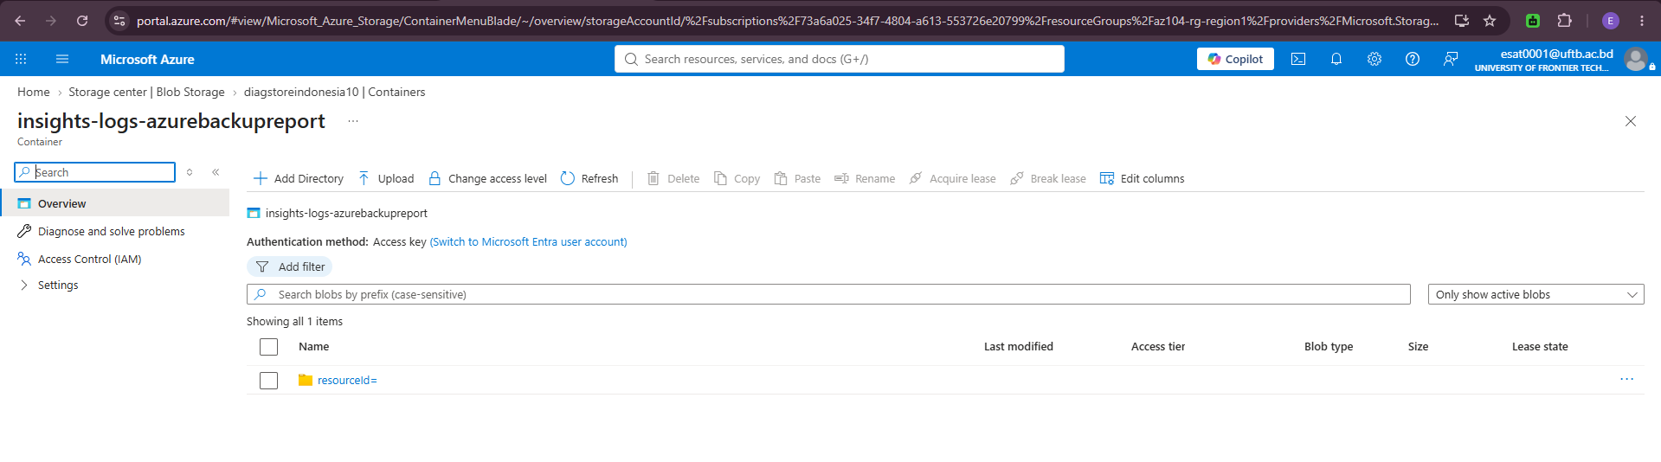
Demonstrates that vault diagnostic logs and metrics are being successfully exported and segregated into dedicated storage containers for compliance, auditing, and long-term security monitoring.
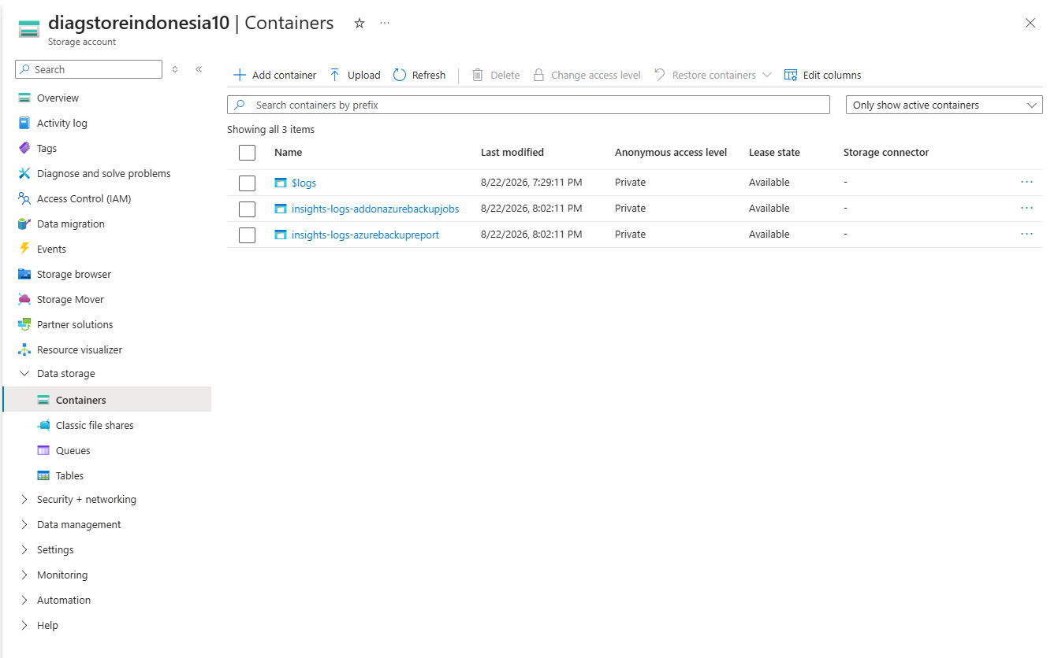
Till Now total cost………
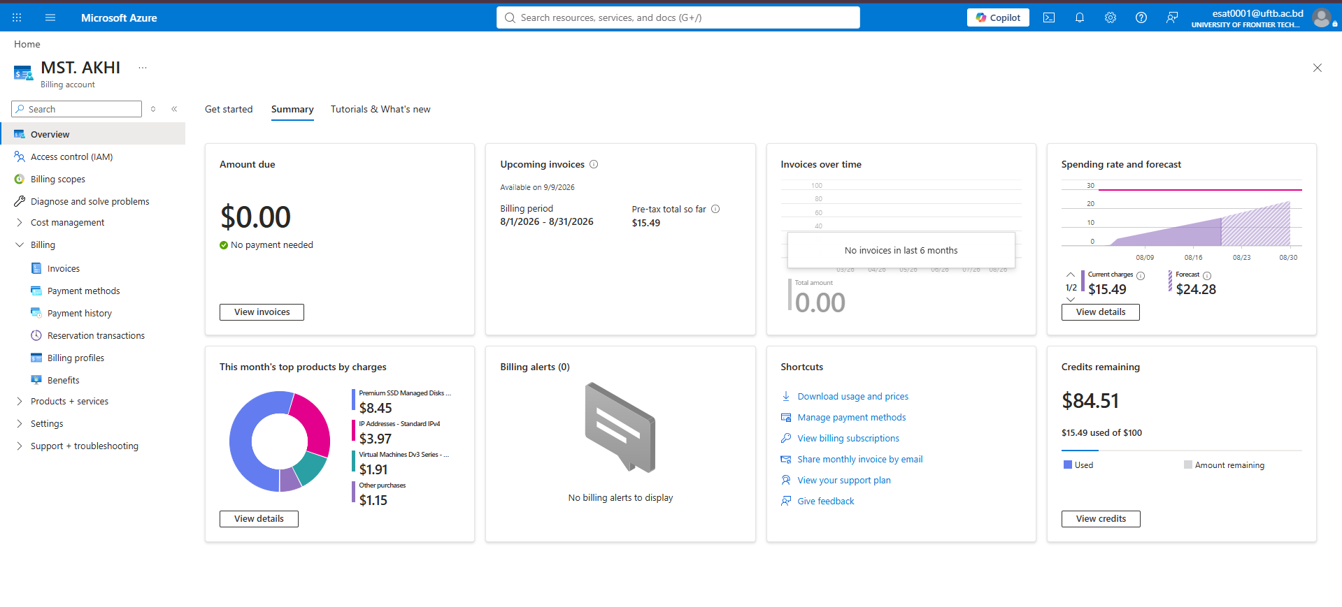

5. Conclusion
The lab successfully demonstrated end-to-end data protection for Azure IaaS Virtual Machines. Operational recovery was achieved through automated backup policies, auditability was established via diagnostic storage archiving, and regional fault tolerance was successfully implemented using Azure Site Recovery.

